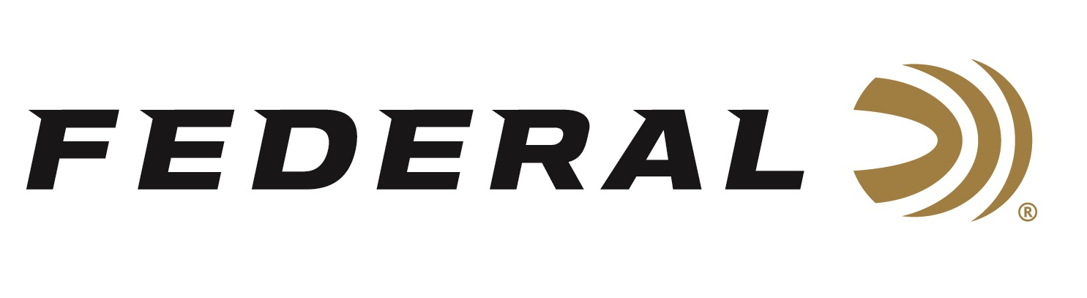

FOR IMMEDIATE RELEASE

Team Federal Welcomes World Champion Kruse to Roster

ANOKA, Minnesota – January 12, 2026 – Federal Ammunition welcomes former World Champion Cory Kruse to its roster of sponsored shotgun shooters in 2026. Kruse joins the team with an extensive list of World and National Championships to his credit.

“Federal is excited to add a shooter and teacher like Cory to our competitive shotgun team,” says V.P. of Marketing Jason Nash. “His list of accomplishments is long and prestigious, and we’re excited he’ll be wearing Federal this year,” continued Nash. “Cory has a great story of starting from humble beginnings and working hard to climb the ladder to eventually winning a World Sporting Championship. That dedication to his craft aligns perfectly with Federal’s core values,” continued Nash.

“I am excited to Join Team Federal,” says Kruse, a Texan who won his first World Championship in FITASC as a Junior in 2003. “I’ve put a lot of time, energy, and training in from a young age and I’m thankful for all the places this sport has taken me and all the people I’ve met along the journey. I look forward to wearing and representing the Federal brand and shooting the best and most reliable products on sporting clays courses in 2026 and beyond,” says Kruse.

Federal Ammunition products, including the new Master Class, are available at dealers nationwide and online. This competition-level sporting clay load features a customized Podium wad that extracts peak performance from utilizing Federal’s straight-wall hull, reliable primers, high-antimony lead shot, and select propellant. For more information on Master Class and all Federal products, visit www.federalpremium.com.

Learn more at: Master Class | Federal Premium

Federal Ammunition products are available at dealers nationwide and online. For more information on all Federal products and to sign up to receive notifications about new product availability, rebate promotions, and other brand news via email, visit www.federalpremium.com.

Press Release Contact: JJ Reich
Senior Manager – Press Relations
E-mail: media@tkghunt.com

About Federal Ammunition
Federal, headquartered in Anoka, MN, is an ammunition brand of The Kinetic Group, owned by CSG, a globally diversified industrial group based in Prague, Czech Republic. Since 1922, Federal has been a leader in ammunition innovation, delivering high-quality sporting and hunting products to shooters worldwide. With a commitment to conservation and the outdoor community, Federal continues to manufacture industry-leading ammunition that enhances the shooting experience while supporting outdoor traditions.

